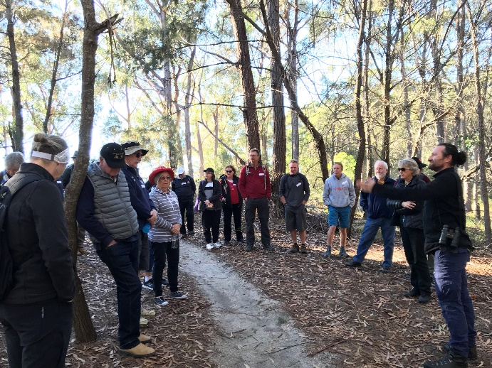
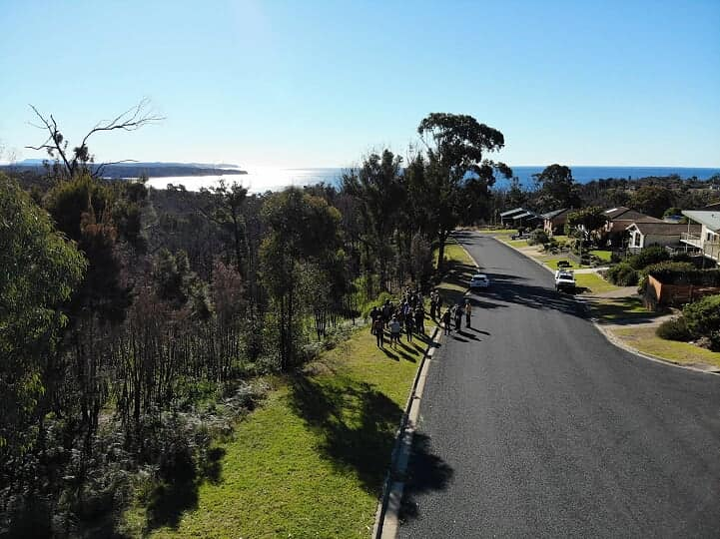
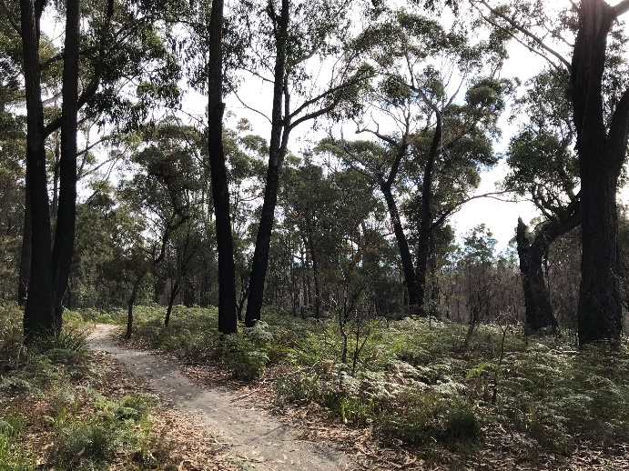
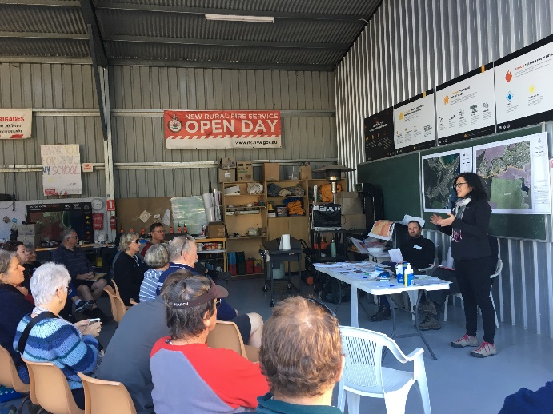
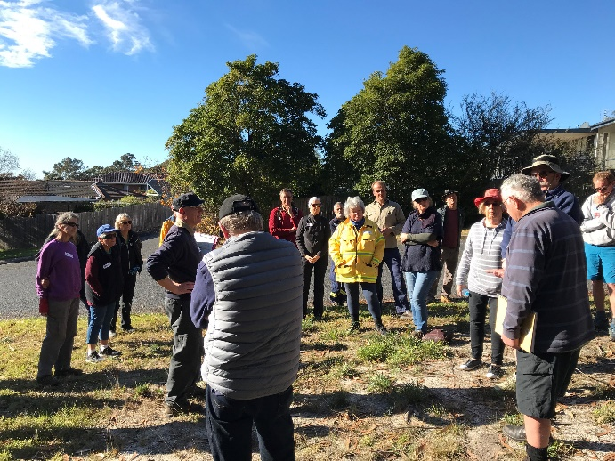
NCC Bushfire Program Workshop
2.
Preparing for Fire in Tathra Headland workshop 2019
The Nature Conservation Council of NSW hosted a Preparing for Fire workshop in Tathra on Sunday 30th June 2019, bringing together 22 local residents and was supported by an additional 11 representatives from the NSW Rural Fire Service, Tathra Rural Fire Service Brigade, Bega Valley Shire Council, National Parks and Wildlife Service.
1.
This peri-urban workshop was part of a series of community engagement events delivered in the Tathra and Tarraganda bush fire affected areas of 2018. This unique cross-agency collaboration included the delivery of workshops from the NCC Bushfire Program, Hotspots Fire Project, and RFS Community Protection Plans.
This community workshop aimed to:
- Provide an introduction to fire ecology, fire behaviour and the role that fire plays in asset protection and biodiversity conservation.
- Provide an understanding of the limits of broadscale burning in providing protection from bush fires.
- Show how property preparation can help to mitigate the risk of bush fire to a community while enabling sustainable management of biodiversity.
- Outline steps that residents can take to mitigate bush fire risk on their property.
3.
Facilitation and Discussion
Workshop participants were welcomed by Evelyn Chia, Bushfire Program Coordinator, at the Tathra Brigade Fire Shed on Sunday morning. Greg Banks, NCC Bushfire Policy Officer, and Mark Graham, NCC Ecologist, led a facilitated discussion throughout the workshop on fire behaviour and the role that fire plays in asset protection and biodiversity conservation. Participants then engaged in a discussion about the limits of broad scale burning in providing protection from bush fires.
4.
“Seeing a way forward after the devastation. Feel more confident if another fire came.”
Workshop participant

5.
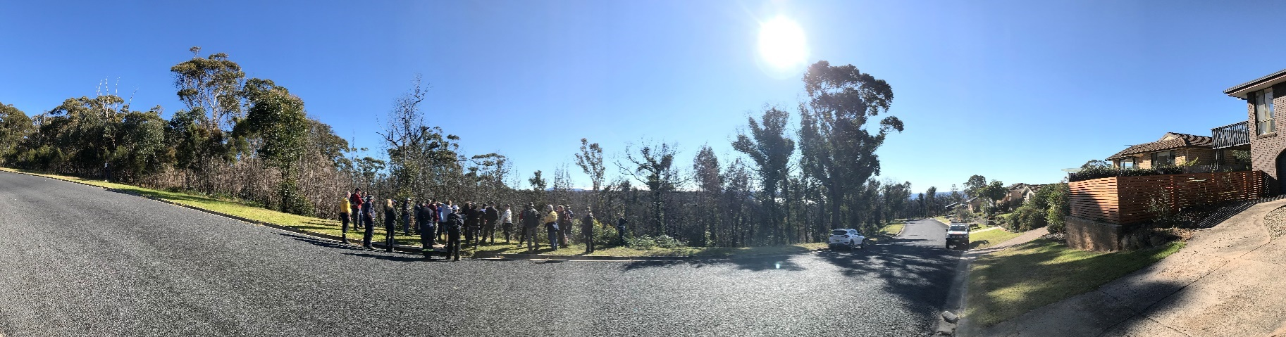

6.

Next, residents were taken on a tour of their local neighbourhood to consider examples of effective property preparation to mitigate bush fire risk whilst enabling sustainable management of biodiversity. Participants were able to observe and interpret fire behaviour and fire management at recently burnt and unburnt sites, and discuss fire ecology, and the local threatened species and habitat.
Throughout the workshop, agency staff shared information and management challenges relevant to their roles, whilst participants were given the opportunity to ask questions, connect with agencies and their community, and share experiences. The workshop finished with a BBQ lunch prepared by the Tathra Fire Brigade.

Participant Feedback
A total of 17 of 22 participants completed the feedback survey, and of these 94% indicated that the workshop was relevant and covered topics that were important to them. 100% of respondents thought that the workshop was well organised and facilitated, and that the workshop fulfilled their expectations.
“Excellent information easily understood.”
“Exceeded my expectations!”
“Understanding the complexity of fire and reasons for appropriate times for hazard burns”
“Stacks of diverse knowledge appreciation of many different roles needed for assessing when/ what/ how to burn.”
Workshop participants
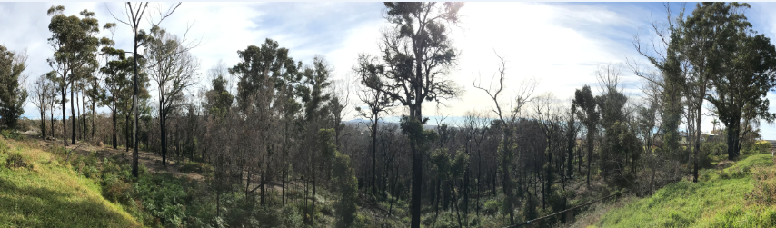
Participants found the workshop valuable because of its collaborative approach between agencies and the community, the sharing of knowledge, the chance to network and learning about how fire impacts local flora and fauna. People indicated that they would update their current Bush Fire Survival Plan, complete their first ever written Bush Fire Survival Plan, do extra maintenance to prepare their home, and make changes to their home/garden for better bush fire protection.
7.

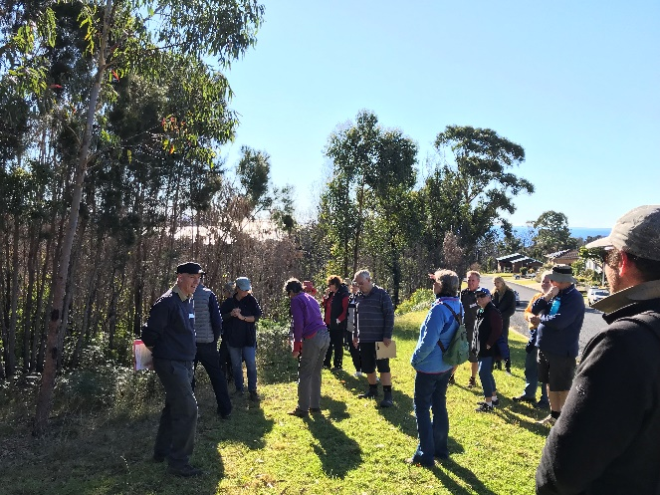
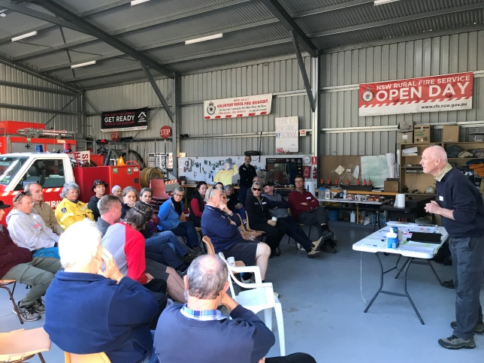
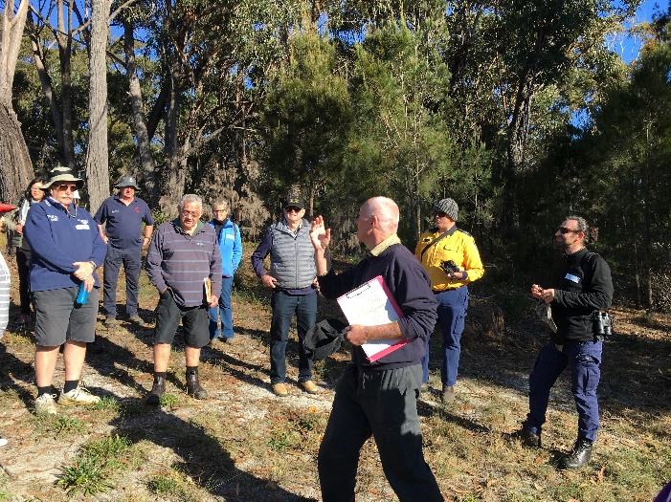

Additional Resources
For further information and resources mentioned during the workshop, please see the following websites:
- An overview of the NCC’s Bushfire Program:
https://www.nature.org.au/healthy-ecosystems/bushfire-program/

- NCC Bushfire Program fact sheets and resources available below including:
https://www.nature.org.au/healthy-ecosystems/bushfire-program/fact-sheets/

- A series of training webinars on how to use numerous online environmental tools
- Creating bird-friendly gardens in fire-prone areas fact sheet
- Information on fire ecology
- Integrated fire and weed management

- Bushfire Program’s fire and restoration website where we share project stories and engage in discussions about how fire is being used to support ecological restoration:
http://fireandrestoration.org.au/

- Resources available from the Hotspots Fire Project including:
http://hotspotsfireproject.org.au/ecological-resources
- Ecological Site Assessment & Monitoring of Bush Fire Management Landholder Guide
- Fire, Weeds and Native Vegetation of NSW
- Fire and Weeds Landholder Booklet
- And many others (please visit website to view the full range)

