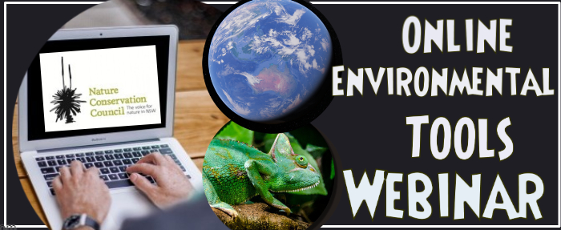
Online Environmental Tools Training
Workshop Report

On Thursday 20th June 2019, the Nature Conservation Council’s (NCC) Bushfire Program hosted an online environmental tools training webinar. The workshop aimed to provide training to individuals in the use of several online tools, to support NCC representatives on Bush Fire Management Committees, volunteers, staff and interested individuals. The content for 2019 was tailored based on participant feedback and requests from the 2018 online tools workshop.

Who participated?
The workshop drew together 11 participants during the live event including Bushfire Management Committee representatives, NCC staff, volunteers and external participants. Several other representatives, who were unable to attend on the day, are able to view the webinar resources uploaded into a series of three parts, all available at: https://vimeo.com/showcase/5239314.

Facilitation and Discussion
The live-stream webinar began with an introduction by NCC Bushfire Program Coordinator Evelyn Chia, followed by a brief overview of 7 environmental online tools profiled at the first webinar by NCC ecologist Mark Graham. These included: BioNet, SEED, Atlas of Living Australia, PlantNet, OEH Threatened Species, Six Maps and Google Earth, all of which were presented at the previous webinar in 2018 (recording available online).
Session One of the workshop provided information about the NSW BioNet Atlas with the expertise of Deyarne Plowman from the Biodiversity Information Systems, NSW Department of Planning Industry and Environment (formally Office of Envrionment and Hertiage). It began with an overview of the NSW BioNet website along with a demonstration of how to use the site. She described the two different kinds of flora and fauna data that can be uploaded onto the BioNet website; via species sightings and systematic surveys. Afterwhich she provided a live demonstration of downloading the spreadsheet, explaining the format and layout, and highlighting the essential steps for data entry and upload. A brief explaination of how to upload data for systematic surveys and differences was also given. A link to draft versions of demonstration videos for the NSW BioNet Atlas developed by the NSW OEH were provided to participants at the end of the session, and the final version of these videos will be provided to all representatives once released on their website. This section of the webinar is directly available here. Additional answers to questions provided after the session are in Appendix 1.
Session Two of the webinar was led by Evelyn Chia, who demonstrated how to review fire history data within Google Earth Pro. Evelyn highlighted the National Parks and Wildlife Service fire history data as it includes records for both wildfires and prescribed burns on public land, and is freely available. Evelyn first illustrated how to download the fire history datasheet (also accessible via the NSW SEED portal), and then import the fire history shapefile into Google Earth Pro, and provided an explanation of the different features that can be displayed, queried, and saved as images. This session can be viewed here.
Session Three of the webinar was led by Mark Graham, who provided insights on the use of NSW Globe topographic data within Google Earth Pro. He demonstrated how to access, import, and interrogate this dataset whilst highlighting the most useful features including, land and parcel property, land tenures, road layers, and topography. Participants were shown the details on the type of information that can be viewed within these layers, and how to save images and/or export maps as PDFs on Google Earth. This section is available online here.
Kevin Taylor who is an NCC Ecologist working with the Hotspots Fire Project provided expert knowledge, commentary and answers throughout the session. Participants were able to interact with the facilitators and each other via text ‘chat’ throughout this live presentation.
These webinar presentations are available online labelled ‘2019’ video series via NCC’s Vimeo page as an ongoing training resource for new representatives and staff. These add to our existing library of training videos and resources which provide a basic demonstration of the steps to search for biodiversity using BioNet, SEED and Atlas of Living Australia. Links to websites and additional resources are listed in Appendix 2.

Feedback from participants and ways to improve
Participants provided very positive feedback; with all indicating that it was well facilitated, the content was useful, and that all sites were likely to be used in the future. Participants particularly valued being kept up to date on available tools and resources, workshop format suited remote representatives, and participants enjoyed the information provided on BioNet. There was consensus from participants for NCC to provide more webinar style training in the future. Suggested improvements will be incorporated into future sessions (e.g. offering to test connection and sound beforehand).
Workshop participants particularly valued:
- Being kept up to date on available tools and resources
- The opportunity to update knowledge, particularly for remote representatives.
- Learning about the possible uses of online environmental tools, including BioNet.

Appendix 1: Additional Questions and Answers on BioNet
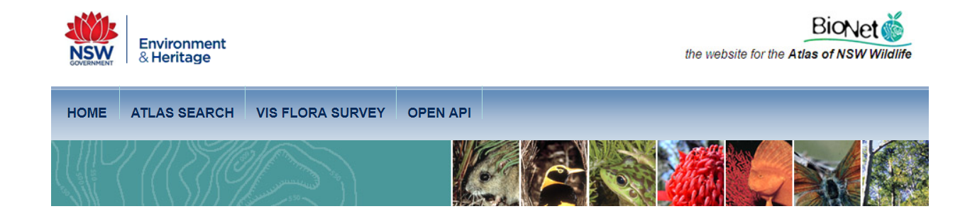
The following includes the answers to questions that were provided after the live webinar.
Question: How many records are currently in BioNet?
Answer: Search criteria: Public Report of all Valid Records of Entities returned a total of 10,890,074 records of 12,249 species. Report generated on 20/06/2019 2:15 PM.
Note, these are valid records. The validation process (not mentioned in the demonstration), involves some records sitting in ‘quarantine’ that are either out of expected location range or potential duplicates – these require review before they are either accepted into the pool of available records, or rejected (and withheld from standard reports).
Question: How should data be recorded in BioNet Atlas for camera traps where the same species is recorded multiple times in one day/night?
Answer:
It depends on the data. As an example, one minute intervals can be used to distinguish between unique animals for Atlas upload for a relative indication activity. In this case, if the same species is recorded within that timeframe then it is treated as the same animal e.g.
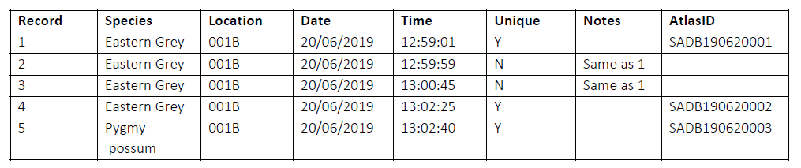
Alternatively, a single record for a time/period survey could be used for presence data.

Appendix 2: Resources and links
- Webinars
- A link to our training videos from both 2019 and 2018: https://vimeo.com/showcase/5239314
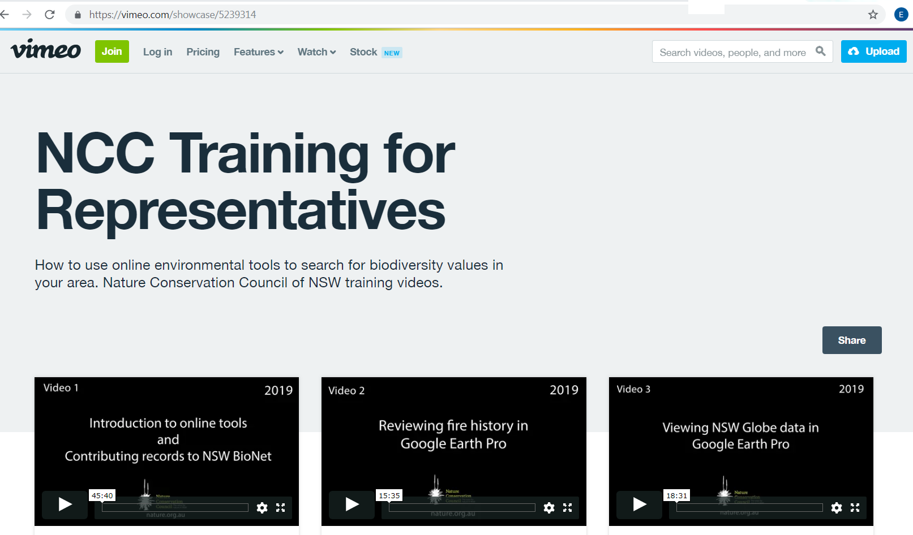

- Websites used on the training day
- BioNet - http://www.bionet.nsw.gov.au/
- Google Earth - https://www.google.com/earth/
- Google Earth Pro (download) - https://www.google.com/earth/versions/#earth-pro
- Spatial Information Exchange (Spatial Services Portal) - https://six.nsw.gov.au/
- SIX Maps - https://maps.six.nsw.gov.au/
- NSW Globe (a data layer for Google Earth) - http://globe.six.nsw.gov.au/

- Websites mentioned during the training
- SEED portal - https://www.seed.nsw.gov.au/
- NPWS Fire history data set via the SEED portal -https://datasets.seed.nsw.gov.au/dataset/fire-history-wildfires-and-prescribed-burns-1e8b6
- Atlas of Living Australia - https://www.ala.org.au/
- PlantNET – http://plantnet.rbgsyd.nsw.gov.au/search/simple.htm
- OEH Threatened Species - https://www.environment.nsw.gov.au/threatenedSpeciesApp/

- Other useful websites
- Geological Maps NSW - https://www.resourcesandgeoscience.nsw.gov.au/miners-and-explorers/geoscience-information/products-and-data/maps/geological-maps
- Australian Government Data - https://data.gov.au/
- Fires Near Me - https://www.rfs.nsw.gov.au/fire-information/fires-near-me
- Bureau of Meteorology - http://www.bom.gov.au/
- OEH Climate Change - https://www.environment.nsw.gov.au/topics/climate-change

